**ERD_&_mapping_lab**

1. Intermediary Car rental company:

An intermediary car rental company has branches across the city; intended to construct a system to facilitate its transactions. You are asked to build an ER diagram and mapping based on the following information.

* The company has many offices to serve a big sector; each office has an ID, address and a contact no.
* The owner welling to rent his car/s needs to provide the office with data about the full name and national ID and the bank account number to which the company will transfer the money.
* The owner must apply for car renting in only one office.
* Owner can apply for renting one or more cars. In addition, it is not allowed to save a car information that is not related to owner.
* Data about car is ID, model (brand, model name, model year), image of its valid license, the rent value and the car status (if the car is booked, in maintenance or available)
* In regard to the tenant (the person who pays rent for the use of a car); the system has to save information about National ID, valid driving license to secure the car and a mobile number as a contact.
* When a tenant orders a car, some information about this transaction have to be known such as the starting date of renting, duration and payment method.

**Mapping:**

**Office** (ID, Address, Contact_Number)

**Owner** (National_ID, Full_name, Bank_account, Office_ID)

**Car** (ID, Brand, Model_year, Model_name, License_Image, Price, Status, Owner_ID)

**Tenant** (National_ID, Driving_License, Mobile_Number)

**Tenant_Rents_Car** (Tentant_ID, Car_ID, Date, Duration, Payment_Method)

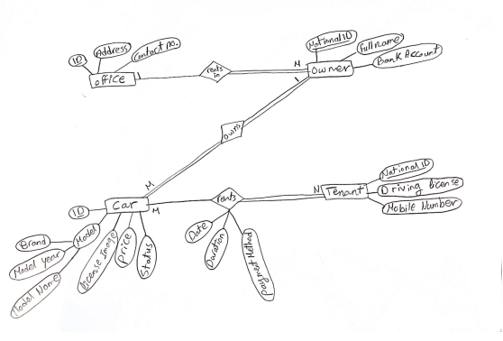

1. XX medical analysis laboratory

A medical analysis laboratory decided to design a system to facilitate data gathering and hence improve the service quality to reach the maximum result accuracy and patient satisfaction accordingly.

You are asked to draw an ER diagram and mapping based on the following information.

* The laboratory has branches in different locations; each branch has a code, short name, detailed address contains the city and area where the branch located in, in addition to the street, building number and floor number as well.
* There is a group of medical tests, which the branch provides. Each test has a code beside the name and cost. Some tests have related conditions to apply to guarantee the result accuracy. The system has to save the duration that each test spends until the result is ready (E.g., each test has specific duration from taking the sample until showing the examination result).
* When the patient visits the branch to perform a test or more, there are some data needed about this patient to record by the system: patient ID, full name, age, mobile number, date of birth, gender and if he/she has chronic diseases.
* The system needs to save the information of which patient visited which branch to perform which test/s, in addition to storing the date and time of performing the test.
* Finally, the system has to keep track of the employees working in each branch. Each employee must serve in one branch only.
* Information required about the employees is; employee ID, full name, salary, team (each employee belongs to a specific team ex: chemists’ team, clean workers team, accountants’ team, doctors team, etc.).
* Each employee has specific duration (e.g. from 8:00 am to 5:00 pm). This duration, starting and ending time have to be recorded.
* In addition, the direct supervisor of each employee has to be considered (if any).
* Every branch must have only one manager who is responsible for it. In addition, no manager is allowed to manage more than one branch.

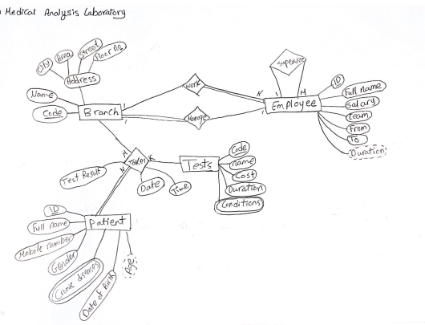

Notes:

* The Participation of the branch in the Branch-Employee relation could be may or must.
* The attributes (from, to) on Employee entity cannot be joined in one attribute, in order to calculate the “duration” derived attribute.

**Mapping:**

**Branch** (Code, Name, City, Area, Street, Floor_No, Manager_ID)

**Employee** (ID, Full_Name, Salary, Team, From, To, Duration, Supervisor_ID, Branch_ID)

**Tests** (Code, Name, Cost, Duration)

**Test_Conditions** (Test_Code, Conditon)

**Patient** (ID, Full_name, Mobile_Number, Gender, Date_of_Birth, Age)

**Patient_diseases** (Patient_ID , Cronic_Disease)

**Branch_Patient_Test** (Branch_Code, Patient_ID, Test_Code, Date, Time, Test Result)

1. XYZ take-away Restaurants:

XYZ take away restaurants chain needs to build a database System helps to capture transactions with accuracy and run every day processes more efficiently. You are asked to draw an ER diagram and mapping based on the following information.

* There are many restaurant branches; each branch has Identification number beside its address and contact number.
* Each branch has its own staff members, which belong to this branch, one member of this staff acts as the branch manager. Each branch must have one manager.
* Each Staff member described by the employee’s full name, ID, age, address that described as (city and region), role, joining date and monthly salary.
* The system is required to track XYZ customers’ information. Each customer has a code on the system, name, and a contact number.
* The system is asked to record the menu items provided by the branch. Some menu items are sharable between the branches. Data about menu item is the code, item name, unit price, item category (e.g. pizza, beverage ...).
* In addition, it is important to track the orders information placed by customers; each order has an ID, desired address to send the order to, total bill as well as the items ordered. The date and time of the placed order are important information to save.
* Each order has one item or more.
* XYZ has the contact numbers and the names of delivery boys

to communicate in case there are orders required to be delivered.

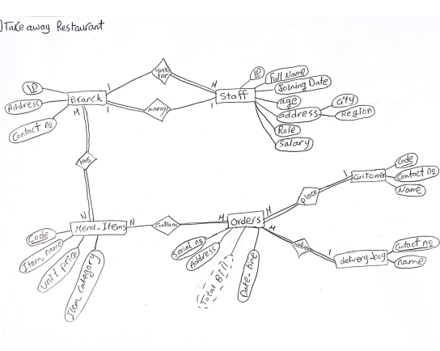

Notes:

* The Participation of Branch in the branch-staff relation could be May or Must.
* Address and Datetime of the order could be attributes on the Order Entity or on the Relatioship between Order and Customer.

**Mapping:**

**Branch** (ID, Address, Contact_number, Manager_ID)

**Staff** (ID, Full_name, Joining_date, Age, City, Region, Role, Salary, Branch_ID)

**Menu_Items** (Code, Item_name, Unit_Price, Item_Category, )

**Orders** (Serial_number, Address, Total Bill, Date_time, Customer_code, Delivery_Boy_number)

**Customer** (Code, Contact_number, Name)

**Delivery_Boy**(Contact_number, Name)

**Branch_Items** (Branch_ID, Item_code)

**Order_Items** (Order_ID, Item_code)

1. International school database system:

A well-known international school seeks to develop a database for its system to ease the data handling process. You are asked to build an ERD and mapping based on the below information.

* Each student of the school has an application (only one) with a unique serial number, furthermore the division in which the student joins (example: American, National or British division).
* Each student is asked to fill in a medical report form with the commencement of joining the school. The medical report has data of weight, length and if the student suffering from any disease/s or has certain types of food allergy. There is no need for the student’s medical report if he/she left our school.
* Every student has his/her own medical report to help in tracking and caring.
* Data about the student are Serial Number, full name, age, gender, date of birth and a copy of completion certificate of his/her last academic year, besides; the school creates an email for each student which has to be added to his record.
* Some students may have siblings in our school; the system has to save this piece of information to consider sibling discount percent.
* The sibling discount recorded.
* The system is required to save information about parents. Parent ID, name, relationship (father/mother).
* On the other hand, the system has to keep track of teacher entity which has attributes; teacher ID, name, subject, phone number, email address and monthly salary.
* Also there is a senior teacher for each group of teachers which teach certain subject, acts as a subject head.
* Each group of students attends in certain class. In addition, the class is dedicated only for them. The class has a unique name, location (building no, floor no), class capacity and attached schedule.
* The system has to save which teacher joins which class.

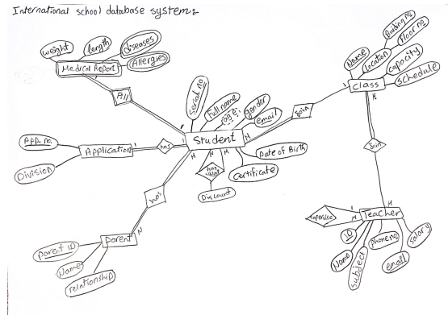

Note: “Allergies” and “Diseases” can be combined into one multi-valued attribute.

**Mapping:**

**Student** (Serial_No, Full_name, Age, Gender, Email, Date_of_Birth, Certificate, Class_name, Application_number, Division, Weight, Length)

**Class** ( Name , Building_number, Floor_number, Capacity, Schedule)

**Teacher** (ID , Name, Subject, Phone_no, Email, Salary, Supervisor)

**Teacher_Class** (Teacher_Id , Class_name)

**Diseases** (Serial_No, Disease)

**Allergies** (Serial_No, Allergy)

**Parent** (Parent_ID, Student_Serial_number, Name , Relationship)

**Student_Parent** (Parent_ID, Student_Serial_number)